Jason Horn

jasonhorn90@webster.edu

Ielectronics and appliances

COSC 6000 Capstone Project

Contents

IElectronics O.M.S. 3

Desired Features 3

User Roles 4

User Requirements 5

Functional Requirements 5

PIECES 6

Non-Functional Requirements 7

Use Cases 8

Table Descriptions 26

Use Case Diagrams 44

Cause/Effect Diagram 49

Problem Statement Matrix 61

Database Schema 62

Contextual Models 62

Sales 62

Purchasing 63

Inventory 63

Payment 64

Screenshots 64

Project Comments 64

# IElectronics O.M.S.

JB & Sons, an electronics company founded by James Burton nearly a century ago, continues to be owned and operated by the Burton family to this day. Currently there are three stores, located in St. Louis, St. Charles and Kansas City, MO. As JB & Sons is family owned and operated, the company maintains a “family oriented” culture, and as such many of the employees have enjoyed lengthy tenure, often exceeding 20 years. Admittedly however, due to the deeply rooted “traditional family approach” to doing business, the company had been slow to incorporate new techniques and technology into the organization.

Although the company does some processing work with regards financial affairs or payroll calculation, data collection remains largely relies on hand-written documents. Data such as employee hours are still collected on time cards and manually entered into the system; and inventory items are cataloged through a card bookkeeping system where each card identifies an inventory item, its name, ID on units on hand; on-hand quantity and re-ordering are manually calculated and adjusted at the warehouse. This results in errors and ambiguity regarding inventory levels, inflated inventory actuals and loss of revenue, overstock sales discounts or missed sales due to products being out-of-stock. Presently there is no visibility or control over on-hand units at the store level; coordination for store units are carried out via telephone to store managers.

# Desired Features

For this project, a web-based application “IElectronics O.M.S (Operations Management System)” will be constructed to facilitate the daily operations of IElectronics and Appliances. The system will be developed using the .NET framework on top of an Oracle database. Features Include:

* Provide interactive online point of sales ability
* Update inventory data at the moment of sales, and persist the information in a database
* Increase inventory control, provide real-time inventory numbers
* Provide inventory reports
* Provide ability to store credit card transactions
* Provide ability to calculate sales commissions and payroll, as well as reporting
* Seamless integration from old to new system
* Purchasing controls must not change

# User Roles

1. Administrator
   1. Admin – frequent use, full access
2. Warehouse Worker
   1. WHMgr – Frequent use, limited access
   2. WHWkr – infrequent use, limited access
3. Buyer
   1. PurchMgr – Frequent use, limited access
   2. Purch – Frequent use, limited access
4. Sales Person
   1. SalesMgr – Frequent use, limited access
   2. Sales – Frequent use, limited access
5. Human Resources
   1. HR – Frequent use, high-level access
6. Store Manager
   1. MGR - Frequent use, limited access
7. Corporate
   1. Corp – Infrequent use, high-level access

# User Requirements

1. A sales commissions report shall be created every Sunday.
2. The system shall maintain real-time inventory data at the warehouse and store levels.
3. The system shall update inventory records at both the time of purchase, and the time of sale.
4. The system shall provide a weekly report detailing all inventory levels
5. The system shall provide a daily report detailing the inventory items that fall below the reorder point.
6. The system shall notify the specific buyers of which items need to be re-ordered.
7. The system shall provide product-specific sales frequency information by month.
8. The system shall provide a weekly report of all products where the sales frequency of the product falls below a specified threshold.
9. The system shall provide real-time information for all product sold, and returned (negative Sales)

# Functional Requirements

1. The system shall record sales information at the moment of sales.
2. The system shall record purchase information at the moment of purchase.
3. The system shall provide real-time inventory information by item and store.
4. The system shall create new employee information.
5. The system shall update employee information.
6. The system shall create new vendor information
7. The system shall update vendor information.
8. The system shall create new customer information.
9. The system shall update customer information.
10. The system shall create new inventory information.
11. The system shall update inventory information.
12. The system shall create new store information.
13. The system shall update store information.
14. The system shall record employee hours worked.
15. The system shall calculate and record payroll information.
16. The system shall calculate and record sales commissions.
17. The system shall provide customizable reports for inventory.
18. The system shall provide customizable reports for payroll.
19. The system shall provide customizable reports for purchasing.
20. The system shall provide customizable reports for sales.

# PIECES

|  |  |  |
| --- | --- | --- |
| **PIECES** | **PROBLEM** | **SOLUTION** |
| **PERFORMANCE** | Manual processes currently in place can result in loss of sales, incorrect inventory assessments | Point of sales system to record and update sales and inventory data in real-time |
| **INFORMATION** | The manual system does not provide adequate reporting for sales, inventory or purchasing. The manual system does not record inventory data at the point of sales | data to be stored in a database, reporting tools driven from live data |
| **ECONOMY** | Loss of sales have occurred due to incorrect stockkeeping. Manual processes for inventory and sales recording are time consuming. | inventory data, driven from live purchase and sales, drives informed decision processes for inventory |
| **CONTROL** | Security is nonexistent - inventory information is physically stored in a card/book process at the warehouse, and most othe data collections are still paper-driven | Role based security to be implemented in the new system |
| **EFFECIENCY** | Due to numerous manual processes, the loosely coupled system is largely ineffecient. | The system will be modular, yet fully integrated |
| **SERVICES** | The systen is rather antiquated, inflexible | The system will be scalable and user-driven |

# Non-Functional Requirements

# Use Cases

|  |  |
| --- | --- |
| **Use Case: Create Employee** | |
| **Primary Actor: HR** | |
| **Scope:** | |
| **Brief:** | |
| **Stake Holders:** | |
| **Post conditions: System records new employee** | |
| **Preconditions: User is logged into the system with appropriate access** | |
| **Triggers:** | |
|  | |
| **User** | **System** |
| Request to create new employee |  |
|  | Provide template |
| Enter new employee information |  |
|  | Accepts new employee information |
|  | Save Record |
|  |  |
|  |  |

|  |  |
| --- | --- |
| **Use Case: Create Customer Account** | |
| **Primary Actor: SalesPerson** | |
| **Scope:** | |
| **Brief:** | |
| **Stake Holders:** | |
| **Post conditions: System records new customer account** | |
| **Preconditions: User is logged into the system with appropriate access, customer account does not exist** | |
| **Triggers:** | |
|  | |
| **User** | **System** |
| Request to create new customer account |  |
|  | Provide template |
| Enter new customer account information |  |
|  | Accepts new customer account information |
|  | Save Record |
|  |  |
|  |  |

|  |  |
| --- | --- |
| **Use Case: Create Employee Profile** | |
| **Primary Actor: HR** | |
| **Scope:** | |
| **Brief:** | |
| **Stake Holders:** | |
| **Post conditions: System records new employee profile** | |
| **Preconditions: User is logged into the system with appropriate access, employee profile does not exist** | |
| **Triggers:** | |
|  | |
| **User** | **System** |
| Request to create new employee |  |
|  | Provide template |
| Enter new employee information |  |
|  | Accepts new employee information |
|  | Save Record |
|  |  |
|  |  |

|  |  |
| --- | --- |
| **Use Case: Create Employee Type** | |
| **Primary Actor: HR** | |
| **Scope:** | |
| **Brief:** | |
| **Stake Holders:** | |
| **Post conditions: System records new employee type** | |
| **Preconditions: User is logged into the system with appropriate access, employee type does not exist** | |
| **Triggers:** | |
|  | |
| **User** | **System** |
| Request to create new employee type |  |
|  | Provide template |
| Enter new employee type information |  |
|  | Accepts new employee type information |
|  | Save Record |
|  |  |
|  |  |

|  |  |
| --- | --- |
| **Use Case: Create Role** | |
| **Primary Actor: HR** | |
| **Scope:** | |
| **Brief:** | |
| **Stake Holders:** | |
| **Post conditions: System records new employee role** | |
| **Preconditions: User is logged into the system with appropriate access, employee role does not exist** | |
| **Triggers:** | |
|  | |
| **User** | **System** |
| Request to create new employee role |  |
|  | Provide template |
| Enter new employee role information |  |
|  | Accepts new employee role information |
|  | Save Record |
|  |  |
|  |  |

|  |  |
| --- | --- |
| **Use Case: Create Customer** | |
| **Primary Actor: SalesPerson** | |
| **Scope:** | |
| **Brief:** | |
| **Stake Holders:** | |
| **Post conditions: System records new Customer** | |
| **Preconditions: User is logged into the system with appropriate access, customer does not already exist** | |
| **Triggers:** | |
| **User** | **System** |
| Request to create new customer |  |
|  | Provide template |
| Enter new customer information |  |
|  | Accepts new customer information |
|  | Save Record |
|  |  |

|  |  |
| --- | --- |
| **Use Case: Create Vendor** | |
| **Primary Actor: PurchMgr** | |
| **Scope:** | |
| **Brief:** | |
| **Stake Holders:** | |
| **Post conditions: System records new vendor** | |
| **Preconditions: User is logged into the system with appropriate access, vendor does not already exist** | |
| **Triggers:** | |
| **User** | **System** |
| Request to create new vendor |  |
|  | Provide template |
| Enter new vendor information |  |
|  | Accepts new vendor information |
|  | Save Record |
|  |  |

|  |  |
| --- | --- |
| **Use Case: Create Store** | |
| **Primary Actor: Corp** | |
| **Scope:** | |
| **Brief:** | |
| **Stake Holders:** | |
| **Post conditions: System records new store** | |
| **Preconditions: User is logged into the system with appropriate access, store does not already exist** | |
| **Triggers:** | |
| **User** | **System** |
| Request to create new store |  |
|  | Provide template |
| Enter new store information |  |
|  | Accepts new store information |
|  | Save Record |
|  |  |

|  |  |
| --- | --- |
| **Use Case: Create Inventory Item** | |
| **Primary Actor: WHMgr** | |
| **Scope:** | |
| **Brief:** | |
| **Stake Holders:** | |
| **Post conditions: System records new inventory item** | |
| **Preconditions: User is logged into the system with appropriate access, inventory item does not already exist** | |
| **Triggers:** | |
| **User** | **System** |
| Request to create new inventory item |  |
|  | Provide template |
| Enter new inventory item information |  |
|  | Accepts new inventory item information |
|  | Save Record |
|  |  |

|  |  |
| --- | --- |
| **Use Case: Update Employee** | |
| **Primary Actor: HR** | |
| **Scope:** | |
| **Brief:** | |
| **Stake Holders:** | |
| **Post conditions: System updates existing employee record** | |
| **Preconditions: User is logged into the system with appropriate access, employee record already exists** | |
| **Triggers:** | |
| **User** | **System** |
| Request to update employee record |  |
|  | Provide list of employees |
| Select employee record |  |
| Updates employee record |  |
|  | Verifies changes |
|  | Saves Record |
|  |  |

|  |  |
| --- | --- |
| **Use Case: Update Vendor** | |
| **Primary Actor: Purch, PurchMgr** | |
| **Scope:** | |
| **Brief:** | |
| **Stake Holders:** | |
| **Post conditions: System updates existing vendor record** | |
| **Preconditions: User is logged into the system with appropriate access, vendor record already exists** | |
| **Triggers:** | |
| **User** | **System** |
| Request to update vendor |  |
|  | Provide list of vendors |
| Select vendor record |  |
| Updates vendor record |  |
|  | Verifies changes |
|  | Saves Record |
|  |  |

|  |  |
| --- | --- |
| **Use Case: Update Customer** | |
| **Primary Actor: SalesMgr, Sales** | |
| **Scope:** | |
| **Brief:** | |
| **Stake Holders:** | |
| **Post conditions: System updates existing customer record** | |
| **Preconditions: User is logged into the system with appropriate access, customer record already exists** | |
| **Triggers:** | |
| **User** | **System** |
| Request to update client |  |
|  | Provide list of client |
| Select client record |  |
| Updates client record |  |
|  | Verifies changes |
|  | Saves Record |
|  |  |

|  |  |
| --- | --- |
| **Use Case: Update Inventory Item** | |
| **Primary Actor: WHMgr, WHWkr** | |
| **Scope:** | |
| **Brief:** | |
| **Stake Holders:** | |
| **Post conditions: System updates existing inventory item record** | |
| **Preconditions: User is logged into the system with appropriate access, inventory item record already exists** | |
| **Triggers:** | |
| **User** | **System** |
| Request to update inventory item |  |
|  | Provide list of inventory items |
| Select inventory item |  |
| Update Inventory Item |  |
|  | Verify changes |
|  | Save Record |
|  |  |

|  |  |
| --- | --- |
| **Use Case: Update Store** | |
| **Primary Actor: Corp** | |
| **Scope:** | |
| **Brief:** | |
| **Stake Holders:** | |
| **Post conditions: System updates existing store record** | |
| **Preconditions: User is logged into the system with appropriate access, store record already exists** | |
| **Triggers:** | |
| **User** | **System** |
| Request to update store information |  |
|  | Provide list of stores |
| Select store |  |
| Update store information |  |
|  | Verify changes |
|  | Save Record |
|  |  |

|  |  |
| --- | --- |
| **Use Case: Record Employee Hours (Clock-in)** | |
| **Primary Actor: WHWkr, Sales, Purch** | |
| **Scope:** | |
| **Brief:** | |
| **Stake Holders:** | |
| **Post conditions: System records employee clock-in time** | |
| **Preconditions: User is logged into the system with appropriate access** | |
| **Triggers:** | |
| **User** | **System** |
| Request to clock in |  |
|  | Request authentication info |
| Enter authentication information |  |
|  | Authenticate employee |
|  | Log employee into the system |
|  | Save Record |
|  |  |

|  |  |
| --- | --- |
| **Use Case: Record Employee Hours (Clock-out)** | |
| **Primary Actor: WHWkr, Sales, Purch** | |
| **Scope:** | |
| **Brief:** | |
| **Stake Holders:** | |
| **Post conditions: System records employee clock-out time, records total hours works and total labor spent** | |
| **Preconditions: User is logged into the system with appropriate access** | |
| **Triggers:** | |
| **User** | **System** |
| Request to clock out |  |
|  | Request authentication info |
| Enter authentication information |  |
|  | Authenticate employee |
|  | log employee out of sytem |
|  | save record |
|  |  |

|  |  |
| --- | --- |
| **Use Case: Create Purchase Order** | |
| **Primary Actor: PurchMgr, Purch** | |
| **Scope:** | |
| **Brief:** | |
| **Stake Holders:** | |
| **Post conditions: System records new purchase order header and purchase order line records** | |
| **Preconditions: User is logged into the system with appropriate access** | |
| **Triggers:** | |
| **User** | **System** |
| Request to create PO |  |
|  | Provide PO Template |
| Enter PO information |  |
|  | Verify PO Information |
|  | Record PO Information |
|  | save record |
|  |  |

|  |  |
| --- | --- |
| **Use Case: Create Sales Order** | |
| **Primary Actor: SalesMgr, Sales** | |
| **Scope:** | |
| **Brief:** | |
| **Stake Holders:** | |
| **Post conditions: System records new sales order header and sales order line records** | |
| **Preconditions: User is logged into the system with appropriate access** | |
| **Triggers:** | |
| **User** | **System** |
| Request to create SO |  |
|  | Provide SO Template |
| Enter SO information |  |
|  | Verify SO Information |
|  | Record SO Information |
|  | save record |
|  |  |

# Table Descriptions

Customer Table

TABLE DESCRIPTION

This table contains data about Customers.

OTHER TABLES REFERENCED

Address

Sales Order

Customer Profile

|  |  |  |  |  |  |  |  |  |
| --- | --- | --- | --- | --- | --- | --- | --- | --- |
| ATTRIBUTE NAME | CONTENTS | TYPE | LENGTH | FORMAT | RANGE | REQ’D | KEY | REFERENCEDTABLE |
| CUSTOMER_ID | Customer Identifier | Numeric | 10 | 999999999 |  | Yes | PK | Update – Restricted  Delete - restricted |
| FNAME | Customer First Name | Varchar | 25 | X(25) |  | Yes |  | Update – Restricted  Delete - restricted |
| LNAME | Customer Last Name | Varchar | 25 | X(25) |  | Yes |  |  |
| PHONE | Primary Phone | Varchar | 10 | X(3-3-4) |  |  |  |  |
| ALT_PHONE | Alternate Phone | Varchar | 12 | X(3-3-4) |  |  |  |  |
| OTHER_INFO | Miscellaneous information | Varchar | 250 | X(250) |  |  |  |  |

SPECIAL RESTRICTIONS

None

Usage Statistics

Address Table

TABLE DESCRIPTION

This table contains data about Addresses.

OTHER TABLES REFERENCED

Customer

|  |  |  |  |  |  |  |  |  |
| --- | --- | --- | --- | --- | --- | --- | --- | --- |
| ATTRIBUTE NAME | CONTENTS | TYPE | LENGTH | FORMAT | RANGE | REQ’D | KEY | REFERENCEDTABLE |
| ADDRESS_ID | Address Identifier | Numeric | 10 | 999999999 |  | Yes | PK | Update – Restricted  Delete - restricted |
| CUSTOMER_ID | Customer Identifier | Numeric | 10 | 999999999 |  | Yes | FK | Update – Restricted  Delete - restricted |
| ADDRESS_TYPE | Main, Alt, etc | Varchar | 25 | X(25) |  |  |  |  |
| STREET | Street Designation | Varchar | 50 | X(50) |  |  |  |  |
| CITY | City Name | Varchar | 25 | X(25) |  |  |  |  |
| STATE | State Code | Char |  | X(2) |  |  |  |  |
| ZIP | Zip Code | Varchar | 10 | X(5-4) |  |  |  |  |

SPECIAL RESTRICTIONS

None

Usage Statistics

Payments Table

TABLE DESCRIPTION

This table contains data about Customer Payments

OTHER TABLES REFERENCED

Customer Account

|  |  |  |  |  |  |  |  |  |
| --- | --- | --- | --- | --- | --- | --- | --- | --- |
| ATTRIBUTE NAME | CONTENTS | TYPE | LENGTH | FORMAT | RANGE | REQ’D | KEY | REFERENCEDTABLE |
| CUSTOMER_ID | Customer Identifier | Numeric | 10 | 999999999 |  | Yes | PK,FK | Update – Restricted  Delete - restricted |
| SALES_TRANSACTION_ID | Transaction Identifier | Numeric | 10 | 9999999999 |  | Yes | PK<FK | Update – Restricted  Delete - restricted |
| PAYMENT_TYPE_ID | Payment type identifier | Numeric | 10 | 9999999999 |  | No | FK |  |
| PAYMENT_AMOUNT | Amount of payment | Numeric | 10 | 99999999.99 |  | No |  |  |

SPECIAL RESTRICTIONS

None

Usage Statistics

Sales Transaction

TABLE DESCRIPTION

This table contains data about Sales Transaction

OTHER TABLES REFERENCED

Employee

|  |  |  |  |  |  |  |  |  |
| --- | --- | --- | --- | --- | --- | --- | --- | --- |
| ATTRIBUTE NAME | CONTENTS | TYPE | LENGTH | FORMAT | RANGE | REQ’D | KEY | REFERENCEDTABLE |
| SALESTRANSACTION_ID | Sales Transaction Identifier | Numeric | 10 | 999999999 |  | Yes | PK | Update – Restricted  Delete - restricted |
| EMPLOYEE_ID | Employee Identifier | Numeric | 10 | 999999999 |  | No | FK |  |
| DATE | Date of Sales Order | Date | 10 | X(99/99/9999) |  | No |  |  |
| Other Info | Miscellaneous information | Varchar | 250 | X(250) |  | No |  |  |

SPECIAL RESTRICTIONS

None

Usage Statistics

Sales Transaction Detail

TABLE DESCRIPTION

This table contains data about Sales Transaction (detail).

OTHER TABLES REFERENCED

Sales Order Header

|  |  |  |  |  |  |  |  |  |
| --- | --- | --- | --- | --- | --- | --- | --- | --- |
| ATTRIBUTE NAME | CONTENTS | TYPE | LENGTH | FORMAT | RANGE | REQ’D | KEY | REFERENCEDTABLE |
| STD_ID | Sales Trans Identifier | Numeric | 10 | 999999999 |  | Yes | PK | Update – Restricted  Delete - restricted |
| Item_Detail_ID | Item Detail Identifier | Numeric | 10 | 999999999 |  | Yes | FK | Update – Restricted  Delete - restricted |
| Bulk_Item_Detail_ID | Bulk Item Detail Identifier | Numeric | 10 | 999999999 |  | Yes | FK | Update – Restricted  Delete – restricted |
| Sales_Transaction_ID | Sales Trans identifier | Numeric | 10 | 999999999 |  | No | FK |  |
| Employee_ID | Employee identifier | Numeric | 10 | 999999999 |  | No | FK |  |
| Quantity | Quantity | Numeric | 10 | 99999999.99 |  | Yes |  |  |
| Price | Price | Numeric | 10 | 99999999.99 |  | Yes |  |  |

SPECIAL RESTRICTIONS

None

Usage Statistics

Bulk Items Detail Table

TABLE DESCRIPTION

This table contains data about bulk items(detail)

OTHER TABLES REFERENCED

Store Location

Bulk Item

|  |  |  |  |  |  |  |  |  |
| --- | --- | --- | --- | --- | --- | --- | --- | --- |
| ATTRIBUTE NAME | CONTENTS | TYPE | LENGTH | FORMAT | RANGE | REQ’D | KEY | REFERENCEDTABLE |
| BULKITEMDETAIL_ID | Unique Identifier | Numeric | 10 | 999999999 |  | Yes | PK | Update – Restricted  Delete - restricted |
| BULKITEM_ID | Unique Identifier | Numeric | 10 | 999999999 |  | Yes | FK | Update – Restricted  Delete - restricted |
| Location_ID | Location Identifier | Numeric | 10 | 999999999 |  | Yes | FK | Update – Restricted  Delete - restricted |
| Available Quantity | Number of items on hand | Numeric | 10 | 9999999999 |  | No |  |  |
| Re-Order Quantity | Number of items on re-order | Numeric | 10 | 9999999999 |  | No |  |  |
| Item Location address | Location where item is stored | Varchar | 50 | X(50) |  | No |  |  |

SPECIAL RESTRICTIONS

None

Usage Statistics

Bulk Items Table

TABLE DESCRIPTION

This table contains data about bulk Items

OTHER TABLES REFERENCED

|  |  |  |  |  |  |  |  |  |
| --- | --- | --- | --- | --- | --- | --- | --- | --- |
| ATTRIBUTE NAME | CONTENTS | TYPE | LENGTH | FORMAT | RANGE | REQ’D | KEY | REFERENCEDTABLE |
| BItem_Number | Unique Identifier | Numeric | 10 | 999999999 |  | Yes | PK | Update – Restricted  Delete - restricted |
| Product_Code | Unique Identifier | Numeric | 10 | 999999999 |  | Yes | FK | Update – Restricted  Delete - restricted |

SPECIAL RESTRICTIONS

None

Usage Statistics

Bulk Price Table

TABLE DESCRIPTION

This table contains data about bulk price.

OTHER TABLES REFERENCED

None

|  |  |  |  |  |  |  |  |  |
| --- | --- | --- | --- | --- | --- | --- | --- | --- |
| ATTRIBUTE NAME | CONTENTS | TYPE | LENGTH | FORMAT | RANGE | REQ’D | KEY | REFERENCEDTABLE |
| BulkPrice_ID | Unique Identifier | Numeric | 10 | 999999999 |  | Yes | PK | Update – Restricted  Delete - restricted |
| BItem Number | Unique Identifier | Numeric | 10 | 999999999 |  | No | FH |  |
| Sales Price | Item Price | Numeric | 10 | 99999999.99 |  | No |  |  |
| Start Date | Start Date | Date |  | xx-xx-xxxx |  | No |  |  |
| End Date | End Date | Date |  | xx-xx-xxxx |  | No |  |  |

SPECIAL RESTRICTIONS

None

Usage Statistics

Item Table

TABLE DESCRIPTION

This table contains data about Items.

OTHER TABLES REFERENCED

Price

Product

|  |  |  |  |  |  |  |  |  |
| --- | --- | --- | --- | --- | --- | --- | --- | --- |
| ATTRIBUTE NAME | CONTENTS | TYPE | LENGTH | FORMAT | RANGE | REQ’D | KEY | REFERENCEDTABLE |
| ITEM_Number | Item Identifier | Numeric | 10 | 99999999.99 |  | Yes | PK | Update – Restricted  Delete - restricted |
| PRODUCT_Code | Product Identifier | Numeric | 10 | 999999999 |  | Yes | FK | Update – Restricted  Delete - restricted |

SPECIAL RESTRICTIONS

None

Usage Statistics

Price Table

TABLE DESCRIPTION

This table contains data about Item price.

OTHER TABLES REFERENCED

None

|  |  |  |  |  |  |  |  |  |
| --- | --- | --- | --- | --- | --- | --- | --- | --- |
| ATTRIBUTE NAME | CONTENTS | TYPE | LENGTH | FORMAT | RANGE | REQ’D | KEY | REFERENCEDTABLE |
| Price_ID | Unique Identifier | Numeric | 10 | 99999999.99 |  | Yes | PK | Update – Restricted  Delete - restricted |
| ITEM_Number | Unique Identifier | Numeric | 10 | 99999999.99 |  | No | FK | Update – Restricted  Delete - restricted |
| Sales Price | Item Price | Numeric | 10 | 99999999.99 |  | No |  |  |
| Start Date | Start Date | Date |  | xx-xx-xxxx |  | No |  |  |
| End Date | End Date | Date |  | xx-xx-xxxx |  | No |  |  |

SPECIAL RESTRICTIONS

None

Usage Statistics

Product Table

TABLE DESCRIPTION

This table contains data about Products.

OTHER TABLES REFERENCED

|  |  |  |  |  |  |  |  |  |
| --- | --- | --- | --- | --- | --- | --- | --- | --- |
| ATTRIBUTE NAME | CONTENTS | TYPE | LENGTH | FORMAT | RANGE | REQ’D | KEY | REFERENCEDTABLE |
| PRODUCT_Code | Product Identifier | Numeric | 10 | 999999999 |  | Yes | PK | Update – Restricted  Delete - restricted |
| PRODUCT_DESC | Product Description | Varchar | 50 | X(50) |  | Yes |  |  |

SPECIAL RESTRICTIONS

None

Usage Statistics

Vendor Table

TABLE DESCRIPTION

This table contains data about Vendors.

OTHER TABLES REFERENCED

None

|  |  |  |  |  |  |  |  |  |
| --- | --- | --- | --- | --- | --- | --- | --- | --- |
| ATTRIBUTE NAME | CONTENTS | TYPE | LENGTH | FORMAT | RANGE | REQ’D | KEY | REFERENCEDTABLE |
| VENDOR_ID | Vendor Identifier | Numeric | 10 | 999999999 |  | Yes | PK | Update – Restricted  Delete - restricted |
| VENDOR_NAME | Vendor Name | Varchar | 50 | X(50) |  | Yes |  |  |
| STREET | Street Designation | Varchar | 50 | X(50) |  | Yes |  |  |
| CITY | City Name | Varchar | 25 | X(25) |  | Yes |  |  |
| STATE | State Code | Char |  | X(2) |  | Yes |  |  |
| ZIP | Zip Code | Varchar | 10 | X(5-4) |  | Yes |  |  |
| PHONE | Primary Phone | Varchar | 10 | X(3-3-4) |  |  |  |  |
| ALT_PHONE | Primary Phone | Varchar | 10 | X(3-3-4) |  |  |  |  |

SPECIAL RESTRICTIONS

None

Usage Statistics

Item Inventory Table

TABLE DESCRIPTION

This table contains data about Item Inventory.

OTHER TABLES REFERENCED

Item Detail

|  |  |  |  |  |  |  |  |  |
| --- | --- | --- | --- | --- | --- | --- | --- | --- |
| ATTRIBUTE NAME | CONTENTS | TYPE | LENGTH | FORMAT | RANGE | REQ’D | KEY | REFERENCEDTABLE |
| Serial Number | Warehouse Identifier | Varchar | 10 | X(10) |  | Yes | PK | Update – Restricted  Delete - restricted |
| Item_Detail_ID | Item identifier | Numeric | 10 | 999999999 |  | Yes | FK | Update – Restricted  Delete - restricted |
| Condition | Item Condition | Varchar | 100 | X(100) |  | No |  |  |

SPECIAL RESTRICTIONS

None

Usage Statistics

Purchase Order Header Table

TABLE DESCRIPTION

This table contains data about Purchase Orders (Summary).

OTHER TABLES REFERENCED

Vendor

|  |  |  |  |  |  |  |  |  |
| --- | --- | --- | --- | --- | --- | --- | --- | --- |
| ATTRIBUTE NAME | CONTENTS | TYPE | LENGTH | FORMAT | RANGE | REQ’D | KEY | REFERENCEDTABLE |
| PURCHASEORDER_ID | Purchase Order Identifier | Numeric | 10 | 999999999 |  | Yes | PK | Update – Restricted  Delete - restricted |
| VENDOR_ID | Vendor Identifier | Numeric | 10 | 999999999 |  | Yes | FK | Update – Restricted  Delete - restricted |
| DATE | Date of Sales Order | Date | 10 | X(99/99/9999) |  | No |  |  |
| Other Info | Misc Info | Varchar | 250 | X(250) |  | No |  |  |

SPECIAL RESTRICTIONS

None

Usage Statistics

Purchase Order Detail Table

TABLE DESCRIPTION

This table contains data about Purchase Orders (detail).

OTHER TABLES REFERENCED

Purchase Order Header

Product

|  |  |  |  |  |  |  |  |  |
| --- | --- | --- | --- | --- | --- | --- | --- | --- |
| ATTRIBUTE NAME | CONTENTS | TYPE | LENGTH | FORMAT | RANGE | REQ’D | KEY | REFERENCEDTABLE |
| POLINE_ID | Purchase Order Line Identifier | Numeric | 10 | 999999999 |  | Yes | PK | Update – Restricted  Delete - restricted |
| PURCHASEORDER_ID | Purchase Order Identifier | Numeric | 10 | 999999999 |  | Yes | FK | Update – Restricted  Delete - restricted |
| Item Detail_ID | Item Identifier | Numeric | 10 | 999999999 |  | No | FK | Update – Restricted  Delete - restricted |
| Employee_ID | Employee Identifier | Numeric | 10 | 999999999 |  | Yes | FK | Update – Restricted  Delete - restricted |
| Bulk Item Detail_ID | Bulk Item Identifier | Numeric | 10 | 999999999 |  | No | FK | Update – Restricted  Delete - restricted |
| QUANTITY | Total of product | Numeric | 10 | 999999999 |  | No |  |  |
| PRICE | Product Cost | Decimal | 10 | 99999999.99 |  | No |  |  |

SPECIAL RESTRICTIONS

None

Usage Statistics

Employee Table

TABLE DESCRIPTION

This table contains data about Employees.

OTHER TABLES REFERENCED

None

|  |  |  |  |  |  |  |  |  |
| --- | --- | --- | --- | --- | --- | --- | --- | --- |
| ATTRIBUTE NAME | CONTENTS | TYPE | LENGTH | FORMAT | RANGE | REQ’D | KEY | REFERENCEDTABLE |
| EMPLOYEE_ID | Employee Identifier | Numeric | 10 | 999999999 |  | Yes | PK | Update – Restricted  Delete - restricted |
| Employee_Type | Employee Type description | Varchar | 100 | X(100) |  | No |  |  |
| Employee_Info | Misc Info | Varchar | 250 | X(250) |  | No |  |  |

SPECIAL RESTRICTIONS

None

Usage Statistics

Store Location Table

TABLE DESCRIPTION

This table contains data about Stores.

OTHER TABLES REFERENCED

None

|  |  |  |  |  |  |  |  |  |
| --- | --- | --- | --- | --- | --- | --- | --- | --- |
| ATTRIBUTE NAME | CONTENTS | TYPE | LENGTH | FORMAT | RANGE | REQ’D | KEY | REFERENCEDTABLE |
| Location_ID | Store Identifier | Numeric | 10 | 999999999 |  | Yes | PK | Update – Restricted  Delete - restricted |
| Address | Store Address | Varchar | 250 | X(250) |  | No |  |  |

SPECIAL RESTRICTIONS

None

Usage Statistics

Sales Commission Table

TABLE DESCRIPTION

This table contains data about Employee Commissions.

OTHER TABLES REFERENCED

Employee

|  |  |  |  |  |  |  |  |  |
| --- | --- | --- | --- | --- | --- | --- | --- | --- |
| ATTRIBUTE NAME | CONTENTS | TYPE | LENGTH | FORMAT | RANGE | REQ’D | KEY | REFERENCEDTABLE |
| Commission_ID | Commission Identifier | Numeric | 10 | 999999999 |  | Yes | PK | Update – Restricted  Delete - restricted |
| Employee_ID | Employee Identifier | Numeric | 10 | 999999999 |  | Yes | FK | Update – Restricted  Delete – restricted |
| DATE | Date of commission | DateTime | 10 | X(99/99/9999) HH:MM:SS |  | Yes |  |  |
| Rate | Rate of Comission | Numeric | 5 | 999.99 |  | No |  |  |
| Amount | Total compensation | Numeric | 10 | 9999999.99 |  | No |  |  |

SPECIAL RESTRICTIONS

None

Usage Statistics

# Use Case Diagrams















# Cause/Effect Diagram



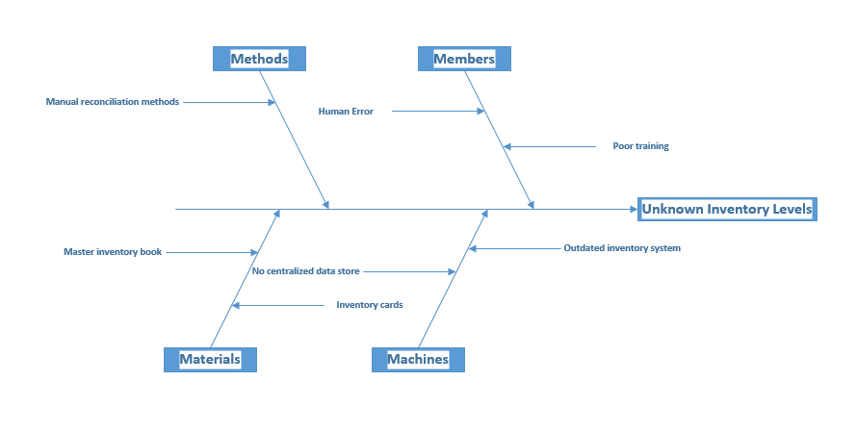

# Problem Statement Matrix

|  |  |
| --- | --- |
| **PROJECT: iElectronics and Appliances** | **PROJECT MANAGER: Ali Ovlia** |
| **CREATED BY: Jason Horn** | **LAST UPDATED BY: Jason Horn** |
| **DATE CREATED: 02/04/2017** | **DATE LAST UPDATED: 03/20/2017** |

|  |  |  |  |  |  |
| --- | --- | --- | --- | --- | --- |
| **Brief Statements of Problem, Opportunity, or Directive** | **Urgency** | **Visibility** | **Annual Benefits** | **Priority or Rank** | **Proposed Solution** |
| 1. Inventory levels are tracked manually at the warehouse | 2 months | High | In the thousands. | 1 | New Development |
| 1. Corporate staff has no control over inventory levels at the store level | 2 months | High | In the thousands | 1 | New Development |
| 3.Inventory reordering process is manual and labor intensive. | 2 months | HIgh | In the thousands | 1 | New Development |
| 4.  Employee hours are recorded manually | 3 months | Medium |  | 2 | New Development |
| 5 Sales commissions are recorded manually | 3 months | Medium | In the thousands | 2 | New Development |
| 6 Sales person evaluations are based on manually recorded data. | 3 months | Medium |  | 2 | New Development |
| 7 No point of sales interface currently exists | 2 months | High | In the thousands | 1 | New Development |

# Database Schema

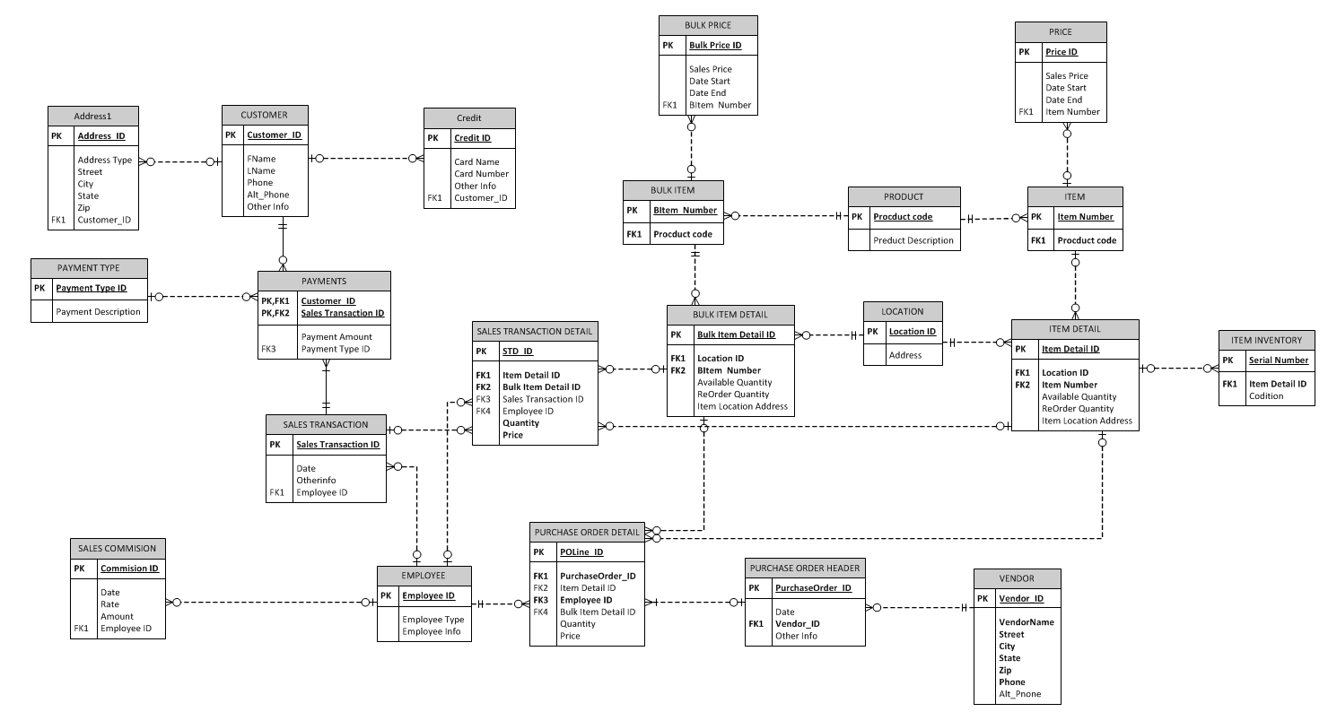

# Contextual Models

## Sales

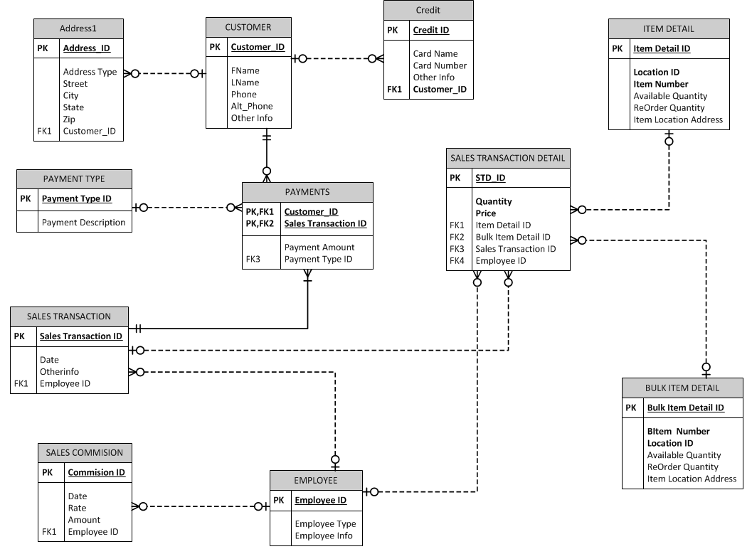

## Purchasing

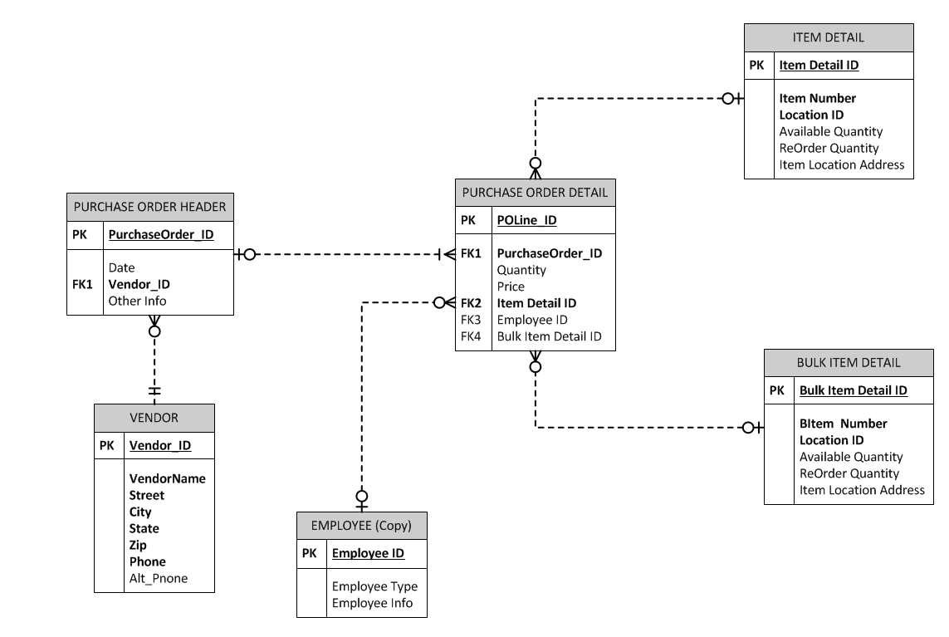

## Inventory

## Payment

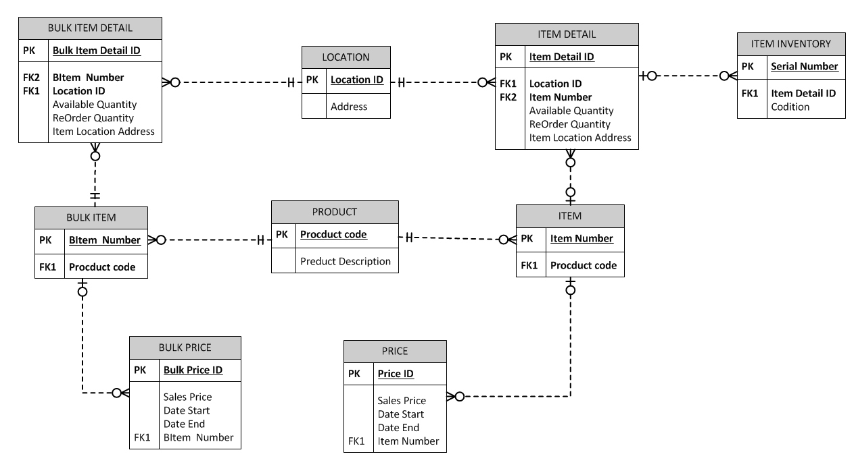

# Screenshots

# Project Comments